Living Theology Friends¹⁴²⁵
Leon L. Combs, M.A., M.Div., Ph.D.
August 24, 2014
“Ephesians 2: 4-7: But God”
Past issues of these letters (~400 so far) may be read at http://livingtheology.com/letters.htm and I encourage you to catch up with them if you have not received earlier letters. Other writings of mine (48 articles and 30 commentaries) are at http://LivingTheology.com and I pray they will be helpful. The author is solely responsible for the content of these letters and they do not represent any particular denomination.

Eph 2:4-7 “But God, being rich in mercy, because of His great love with which He loved us, ⁵even when we were dead in our transgressions, made us alive together with Christ (by grace you have been saved), ⁶and raised us up with Him, and seated us with Him in the heavenly places, in Christ Jesus, ⁷in order that in the ages to come He might show the surpassing riches of His grace in kindness toward us in Christ Jesus.”

Perhaps the two most wonderful words in the Bible are “But God”! We were without hope, wandering in the world only directed by the natural course of the world stream as directed by Satan (Eph 2:1-3). Then we read “But God!” He acted on our behalf because He is rich in mercy and He has such a great love for us, His chosen children (Eph 1:4). These four verses are so rich that we could never fully comprehend them. Before our regeneration, God’s attitude toward us was as is stated in: “He who believes in the Son has eternal life; but he who does not obey the Son shall not see life, but the wrath of God abides on him.” (John 3:36) It is this verse that led me to draw the black cloud of God’s wrath above the spiritually dead man in this figure depicting mankind before regeneration:
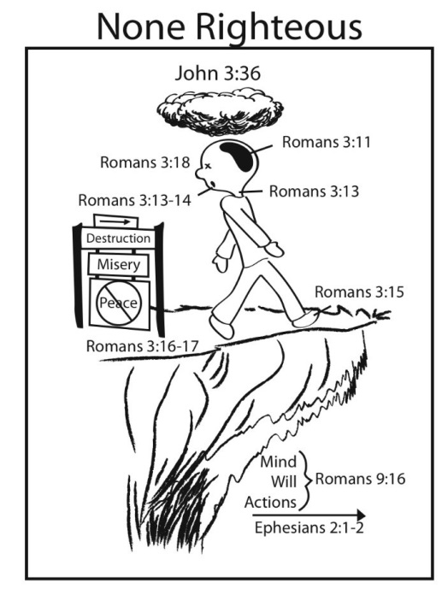
The wrath of God was abiding on us before our regeneration! We were without hope and doomed to have the wrath of Holy God poured out on us. That is not a good situation! But God had mercy on us and He “made us alive in Christ Jesus”. He brought us from being spiritually dead to being spiritually alive. We were “born again” which Jesus said in John 3:3 must happen before we can see the kingdom of heaven. After this rebirth, we are a body, a soul, and a living spirit. We were born again into the image of God. But that is not all that He did! He raised us up with Christ Jesus and sat us in the heavenly places. Of course this event of placing us in heaven is a spiritual event, but that doesn’t make it any less real. Spiritually we are sitting in heaven with God and one day He is going to reveal this fact to the entire world so that “He might show the surpassing riches of His grace in kindness toward us in Christ Jesus”. One day the triune truth will be revealed so that everyone will know what God has done. Everyone will be able to see the mercy that God has shown to His children and His riches and grace in kindness will be clearly revealed. The rest of the world will perish.

A “belief” is only necessary when the fact is not clearly revealed for one to see and understand. One day some of the people that you know who are not God’s children will look at you sitting in the heavenly places and gasp at the sudden realization that what you had been telling them about God was indeed true. The awful horror will come upon them that it is too late for them to join you. These totally worldly people will receive perfect justice whereas we who were chosen by God obtained mercy. We had agreed with God that we were guilty, but He used the perfect payment of Jesus Christ to pay for all of our guilt. All other people will have to pay for all of eternity for their guilt. God’s justice will be perfect. Those people who are not God’s children will have their good works and their evil works revealed and judged by God. For all of eternity the payment for their guilt will be perfectly consistent with credit for their works.

These verses reveal the true essence of Christianity and of all Christians. Our belief is a result of what God did first. People can start and stop believing certain things on their own initiative. But we who are born again have a belief and a hope that are certain in our minds because we have new hearts, minds, eyes, and ears. We have a new way of understanding that we did not possess before God acted: “But a natural man does not accept the things of the Spirit of God, for they are foolishness to him; and he cannot understand them, because they are spiritually appraised.” (1 Cor 2:14) True children of God will never stop believing in Him because this belief is now a part of our being. Note that the verbs in these sentences are past tense. We were made alive, raised up, and seated in the heavenly places. These are events that happened when we became the children of God. Also note that we see the joining of us “in Christ” in all of these events. Just as God the Father did all of these events for Jesus, He also has done them for us. It is accomplished already and nothing that we do or don’t do will affect what God has already done.

These verses describe the Christian, who is a new person. We still have many of the same attributes that we had before (brain, physical heart, and other physical aspects), but now we have a new intent about life. The Christian has a desire to please God and access to God through Jesus Christ. We are being spiritually matured by the Holy Spirit in our walk in the world. We no longer look at anything the same as we did before our regeneration. All aspects of our lives are seen through a new viewpoint. We have our focus on Jesus. We judge all of our thoughts and actions upon our new spiritual insight as to what is profitable in the “true long term”. We are citizens of heaven and judge everything by the acceptable and profitable revealed Word of God. Praise God for those wonderful words: “but God”!

