GENESIS
Lesson Eight
Gen 6:14-7:24

Gen 6:14-17 "Make for yourself an ark of gopher wood; you shall make the ark with rooms, and shall cover it inside and out with pitch. ¹⁵"And this is how you shall make it: the length of the ark three hundred cubits, its breadth fifty cubits, and its height thirty cubits. ¹⁶"You shall make a window for the ark, and finish it to a cubit from the top; and set the door of the ark in the side of it; you shall make it with lower, second, and third decks. ¹⁷"And behold, I, even I am bringing the flood of water upon the earth, to destroy all flesh in which is the breath of life, from under heaven; everything that is on the earth shall perish.

An ark is just a floating container that is not designed to go anywhere. The word “ark” is of Egyptian origin and used by them for carrying grain and for transporting their golden images across the Nile. Noah’s ship was also similar to those used by the Egyptians on long voyages over rough seas. Since Moses was educated in Egypt, it is not surprising that he would have been familiar with such vessels. Also since the Egyptians are descendents of Ham, perhaps they learned this method of construction from his lineage! His mother used a similar construct for Moses when she put him afloat: Exodus 2:3 But when she could hide him no longer, she got him a wicker basket and covered it over with tar and pitch. Then she put the child into it, and set it among the reeds by the bank of the Nile. The material used was “gopher wood” and it is unknown precisely what type of wood this was. Some translators translate it as cypress wood as is in the above quotation. It is also uncertain as to what exactly was the “pitch” although its purpose was certainly to make the vessel waterproof. If it was tar as we know it today, it would have originated from many years of decomposed organic matter.

The actual value of a cubit has been debated for the Babylonians had a cubit of 20 inches and the Egyptians had a cubit of about 17 inches. Since Moses was educated in Egypt we should consider the Egyptian cubit, as well as the Hebrew cubit. Hebrew common cubit = 17.5 in. Egyptian Royal cubit = 20.65 in. Most Biblical scholars think the Hebrew cubit was about 18 inches. Using that value of a cubit, the arc would have been 450 feet long, 75 feet wide and 45 feet high. This was a huge “box”! It was also extremely stable and almost impossible to capsize. It was not until 1858 that a longer boat was built called the Great Eastern that was 692 feet by 83 feet by 30 feet. The boat we sailed on for our Baltic cruise was 630 feet long. We see that the ark had three decks, only one window, and only one door. The Hebrew word translated “window” above is only used here in the OT and is disputed by scholars. Some translations of verse 16 read: “Make a roof for it and finish the ark to within 18 inches of the top.” The word is similar to that in some Semitic languages and some think it refers to having a place where light can enter the ark and this is why some people translate it as “window”. Exactly what is finished one cubit from the top is also in doubt and some people think it means that the opening itself was one cubit in height, which would make it appear like used in Egyptian houses. Most people depicting the Ark put ventilation openings across the top for such certainly seems necessary for all that was contained in it. In Noah’s day, the earth was watered evidently by very dense fogs (Gen 2:6) so a flood was not something they could contemplate.

We do not know exactly how long it took to build the ark for the Bible does not explicitly tell us. In Gen 6:3 we read: Gen 6:3 Then the Lord said, "My Spirit shall not strive with man forever, because he also is flesh; nevertheless his days shall be one hundred and twenty years." It would seem that this time is the time from God telling Noah about the coming destruction and it actually happening. We also read the age of Noah at the time of the flood beginning: Gen 7:6 Now Noah was six hundred years old when the flood of water came upon the earth. We read of another age of Noah: Gen 5:32 And Noah was five hundred years old, and Noah became the father of Shem, Ham, and Japheth. The context of this verse is not clear to me (the two “and” words are confusing to me) but it could mean this was the time when God began to tell Noah about the destruction coming (Gen 6:1-3). If he was 500 years old when he became a father of the three sons then they were 100 years old when the flood came. But, unless the sons were triplets and we take the verse to mean that the three were born when Noah was 500 years old, we do not know precisely when they were born. Gen 6:10 repeats concerning his sons: Gen 6:10 And Noah became the father of three sons: Shem, Ham, and Japheth. Context is difficult here and it even seems like 6:8-10 belong immediately after 5:32.

It seems that it took between 100 and 120 years for the ark to be build. Since there is no clear verse telling us exactly when Noah began to construct the Ark as commanded in Gen 6:14, we cannot know how long Noah spent building it. This does not seem important to me. We just know that, by faith, he built the Ark:
Heb 11:7 By faith Noah, being warned by God about things not yet seen, in reverence prepared an ark for the salvation of his household, by which he condemned the world, and became an heir of the righteousness which is according to faith.

Several people have built replicas of the ark. Two pictures from the Netherlands boat exhibit are below:

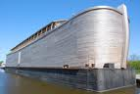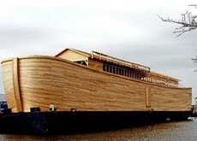

Here is from the Hong Kong exhibit:

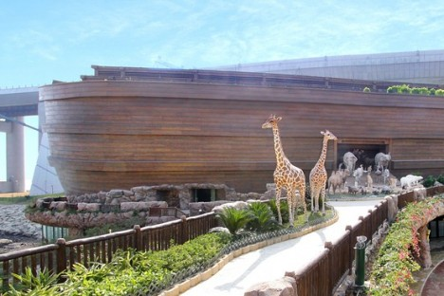

Here are two pictures from a book showing how the inside of the ark may have appeared:
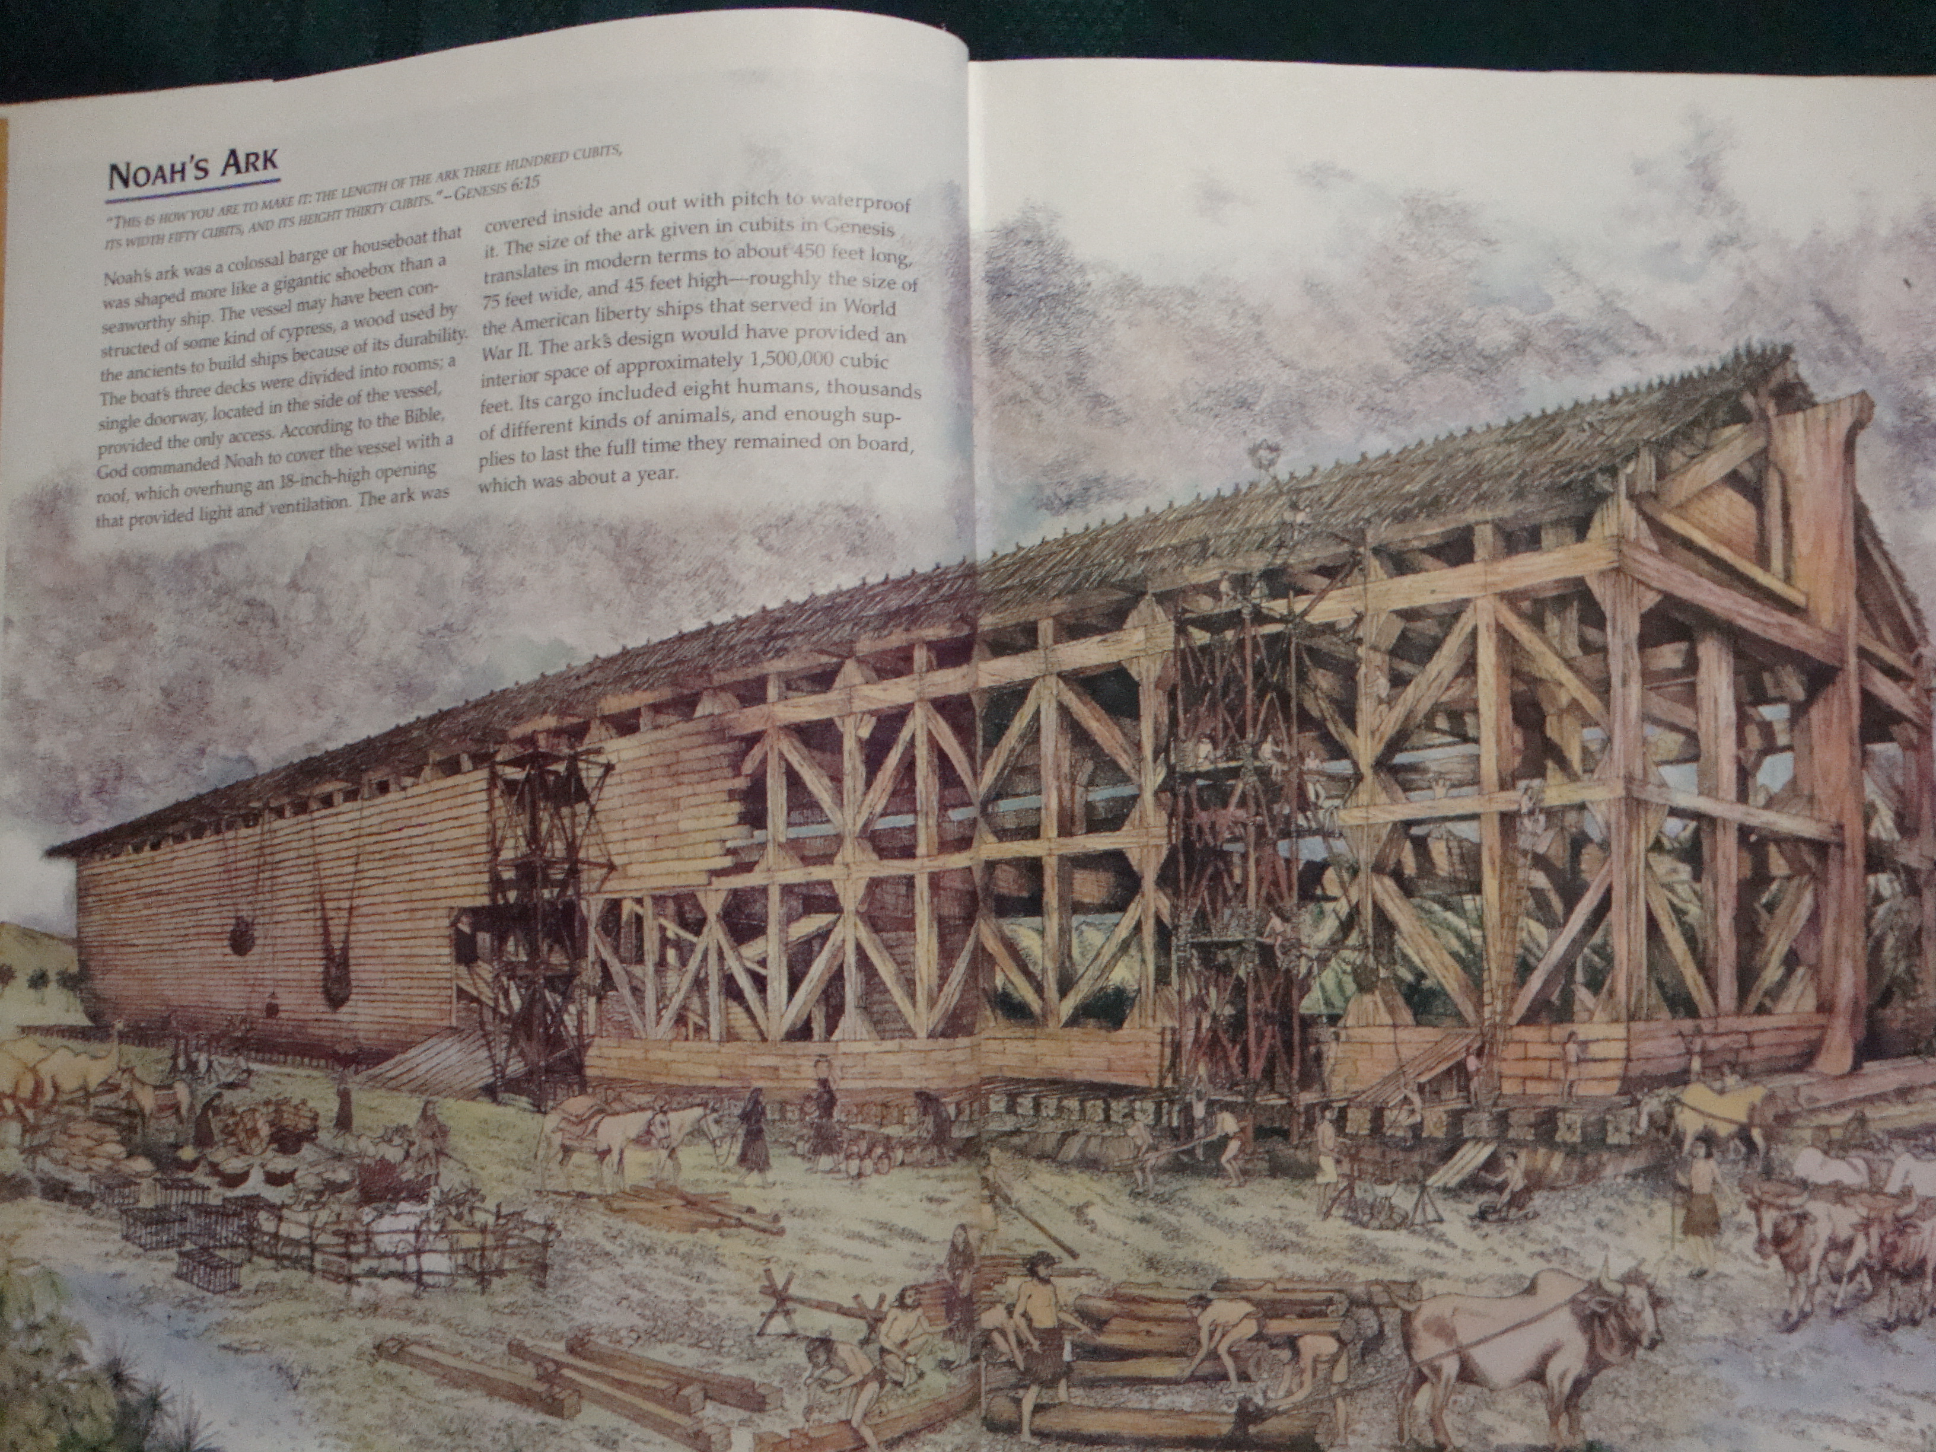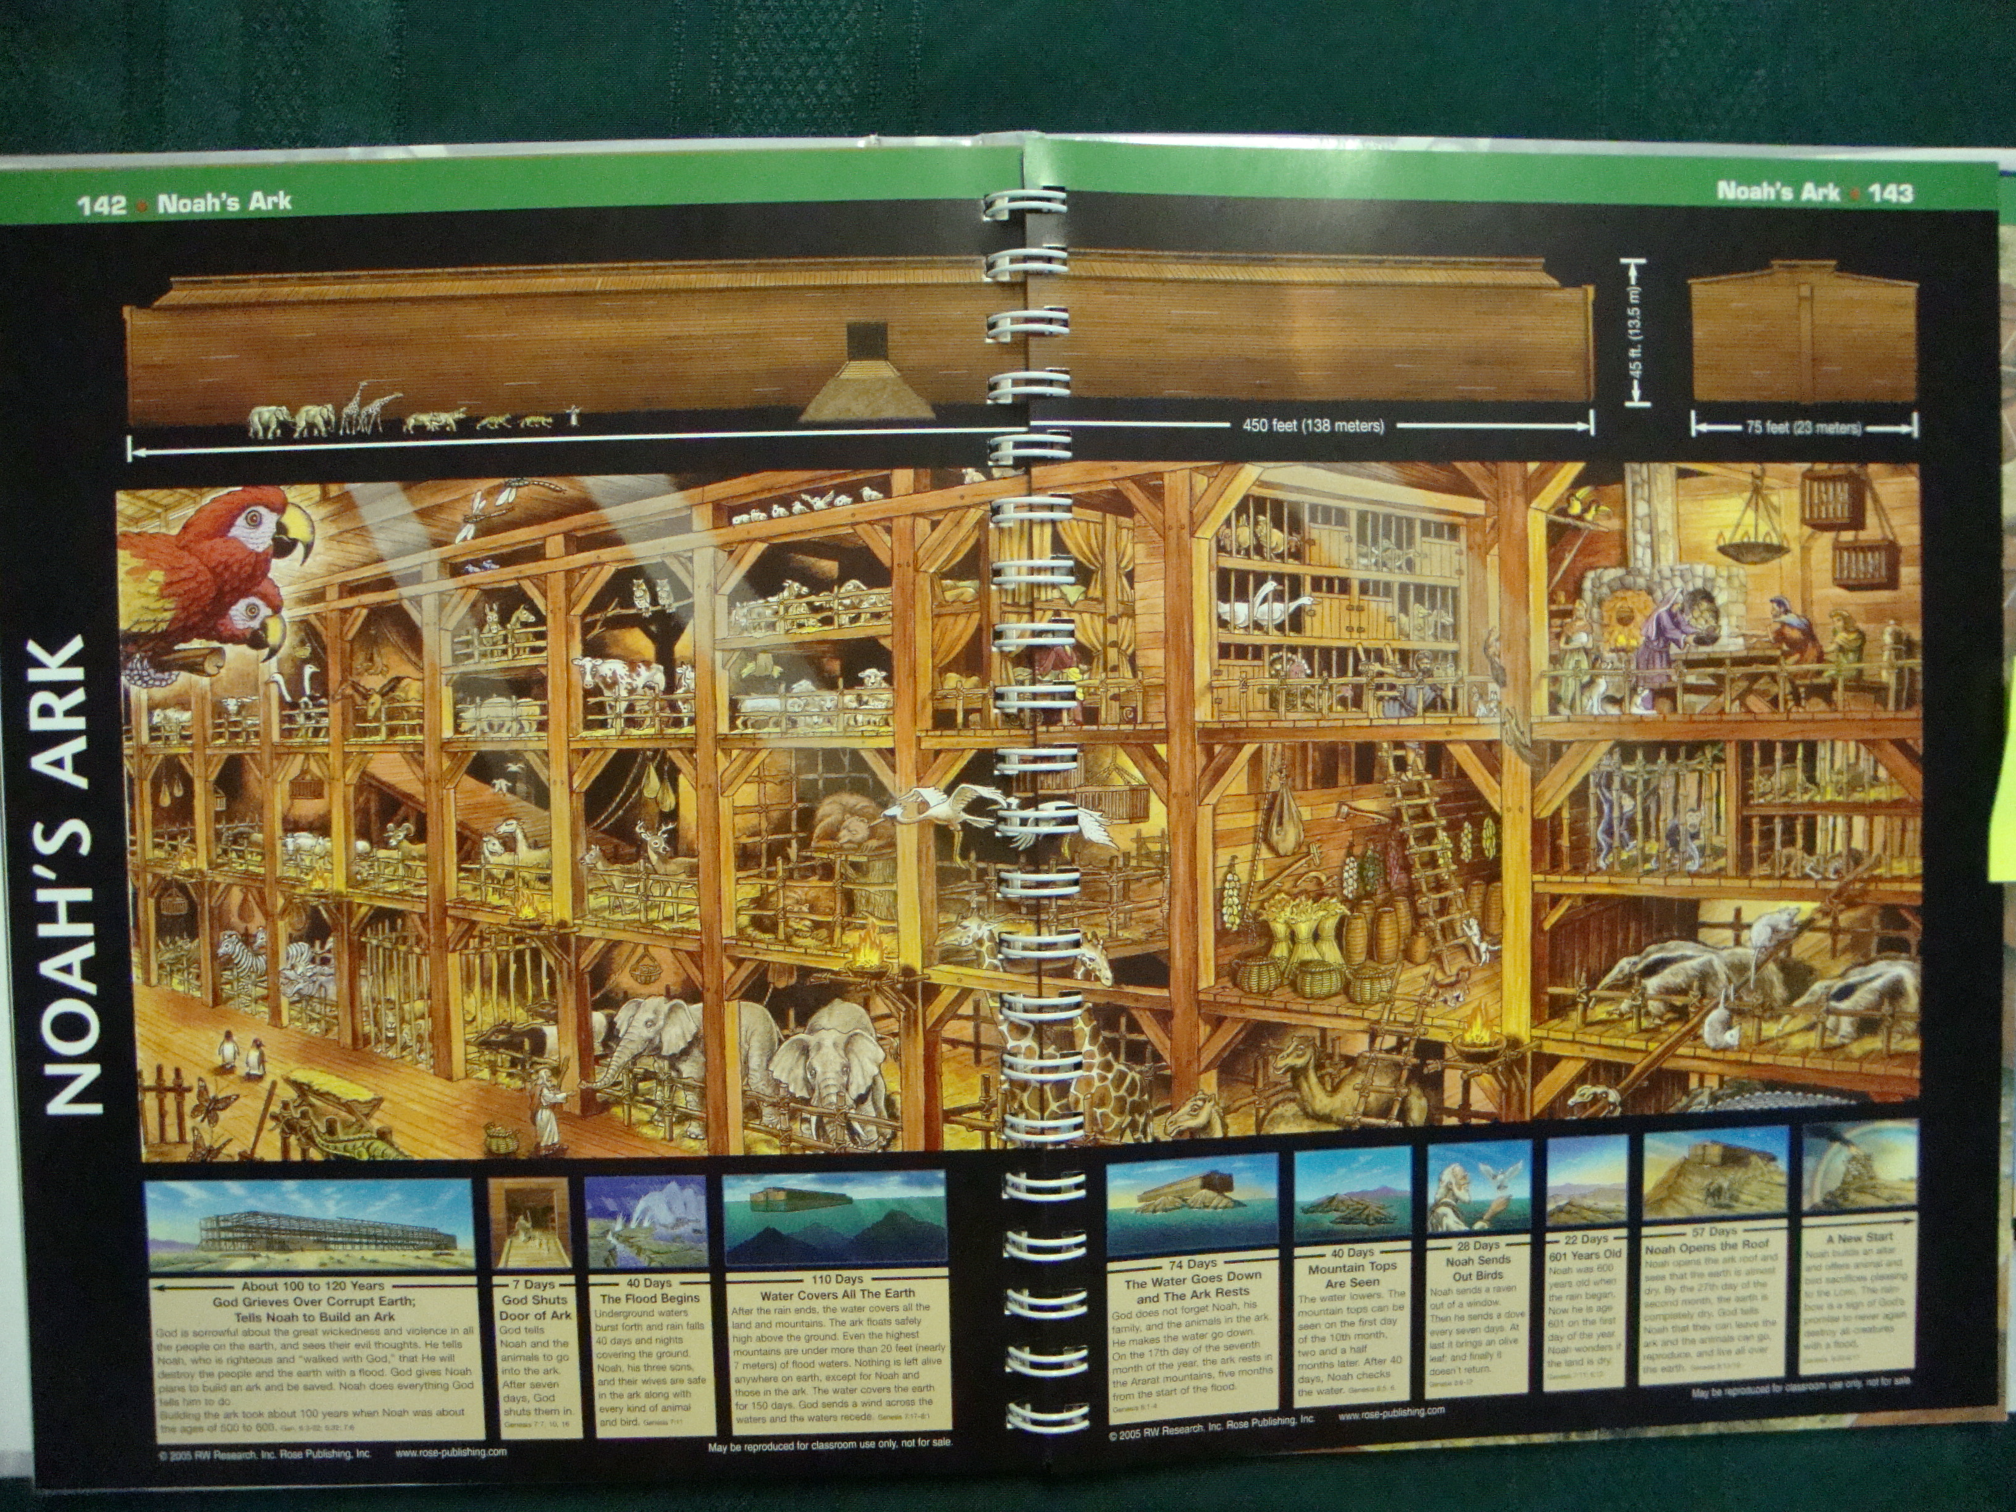

Gen 6:18-22 "But I will establish My covenant with you; and you shall enter the ark-- you and your sons and your wife, and your sons' wives with you. ¹⁹"And of every living thing of all flesh, you shall bring two of every kind into the ark, to keep them alive with you; they shall be male and female. ²⁰"Of the birds after their kind, and of the animals after their kind, of every creeping thing of the ground after its kind, two of every kind shall come to you to keep them alive. ²¹"And as for you, take for yourself some of all food which is edible, and gather it to yourself; and it shall be for food for you and for them." ²²Thus Noah did; according to all that God had commanded him, so he did.

Here is the first use of the word “covenant” in the Bible. A covenant is then defined as “a bond in blood sovereignly administered by God.” It is a bond that is sovereignly administered by God. I would say the basic assertion of a study of covenants is that God’s work with man began before the foundation of the world and has continued without ceasing. I think that we can indeed say that there are five divine covenants that God has made with man:

- Redemption and/or Creation
- With Adam
- With Noah
- With Abraham
- With Moses
- With David
- In Jesus

From an affirmation that all of these divine covenants exist certainly leads us to the conclusion that God’s purpose in creation is to have a forever relationship with His divine creation: spiritually complete man. Of course we are always safe to say that God’s purpose always is to glorify Him and that is done in its entirety with the adoption of His children into His kingdom.

I have seven divine covenants listed in contrast to some teachings. Some books combine the first two that I have listed. However I think such an interpretation gives us an incomplete picture of God’s plan. Some teachers also separate my first two covenants and then talk about a separate covenant of redemption and creation, but then merge the creation covenant with the Adamic Covenant. Creation is covenantal, as Jeremiah 33:20-26 asserts even though there is no mention of “covenant.” But the fact that there was a covenant before creation is also clear from Scripture where we are told of the interaction between the Godhead that the Father would send Jesus to live the perfect life that no mere human could live, that He would die and be resurrected for the sins of man, and that the Holy Spirit would then gather the chosen people to Jesus for cleansing and adoption as Children of God. We call this the Redemption Covenant in which the Trinity made the covenant to finally provide for the redemption of all of God’s chosen children throughout all ages. I have lumped together this Redemption Covenant and the Creation Covenant because both occurred before the time of Adam.

The next covenant is that with Adam. We have a Scriptural proof of the validity of this covenant:
Hos 6:7 “But like Adam they have transgressed the covenant; There they have dealt treacherously against Me.”
The above clearly states that Adam was in covenant with God. We also see the fundamental aspects of the covenant including the blood aspect:

1. Demonstration of grace with the garments of skin and the shedding of blood
Gen 3:21 “And the Lord God made garments of skin for Adam and his wife, and clothed them.”
2. The promise of a seed
Gen 3:15 “And I will put enmity Between you and the woman, And between your seed and her seed; He shall bruise you on the head, And you shall bruise him on the heel.”
3. Made with Adam and Eve as representatives of all mankind.
Rom 5:12 “Therefore, just as through one man sin entered into the world, and death through sin, and so death spread to all men, because all sinned”

The Covenant of Redemption (CR) began before God created time, the universe, the earth, and Adam and Eve but continued into those creations. The CR included God’s ultimate plan for the redemption of His people for His glory and overarches all the other covenants. Using abbreviations for space (CA for Covenant with Adam, CN with Noah, CA with Abraham, CM for Moses, CD for David, and CJ for Jesus) we can show the following:
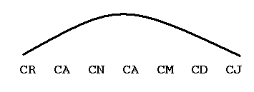
God has always been in plan A! All the intervening five covenants from Adam to David are fulfilled with Jesus. Many scholars see a correlation of Jesus and the ark in that only some people are chosen to be “in Jesus” and the covenant is also correlated with the new covenant with Jesus.

God gave Noah specific instructions on bringing in animals whose kind would have been destroyed in a flood. Regarding the number of species put on the boat, it is difficult to determine the exact meaning of the Biblical word “kind” but if it corresponds to our modern “family” the maximum number would be about 700. But if “kind” is similar to our “species” then the number would be much larger. Experts in this area have estimated that the total number would be somewhat over 1,000, 000 but not all of them would have to be in the ark. There are over 20,000 species of fish and they were not on the ark. Subtracting similar species leaves a number between 35,000 and 70,000 animals, one male and one female. The volume of the ark would equal 569 two-deck railroad cars and calculations show that the animals saved would fit into about 50% of the ark’s capacity. Thus there would be plenty of room for people, food, water, and other provisions for the stay in the ark. God also commanded Noah to keep them alive and He told him to bring in the necessary provisions needed for all animals and Noah and his family. Noah was faithful in doing all that God commanded.

Gen 7:1-5 Then the Lord said to Noah, "Enter the ark, you and all your household; for you alone I have seen to be righteous before Me in this time. ²"You shall take with you of every clean animal by sevens, a male and his female; and of the animals that are not clean two, a male and his female; ³also of the birds of the sky, by sevens, male and female, to keep offspring alive on the face of all the earth. ⁴"For after seven more days, I will send rain on the earth forty days and forty nights; and I will blot out from the face of the land every living thing that I have made." ⁵And Noah did according to all that the Lord had commanded him.

Some translations interpret “enter the ark” as “come into the ark”. He told Noah and his household to enter the Ark and God further specified that he was to bring aboard more clean animals than unclean animals. This stipulation is an elaboration of the earlier text regarding one pair of each kind for God intended that there was to be a sacrifice of clean animals at the close of the flood account (8:20-21). Since the definitions of clean animals occurred after the flood (Lev 11), it is not possible to determine how Noah made these choices. Since Leviticus makes distinctions between clean and unclean species they must have existed at that time. But if they were not chosen for the ark then they were destroyed in the flood. So since later God told the Jews that some of their animals were unclean, the Jewish distinctions for occupancy in the ark could not have been used. Something else we cannot know! Certainly the animal sacrifice of Abel was accepted by God so perhaps the distinction was made clear to Abel who we remember was a prophet.

It is not possible to know if there would be 14 or 7 total of each clean type of animal although 7:9 states all went into the ark in pairs so it seems that there were 14 of each clean animal. The specification of male and female is to make sure that propagation occurs. Again it is stressed that the reason for saving only these eight people was because of the righteousness of Abraham before God and we remember that God’s grace on Noah preceded him being declared righteous. He then told Noah that in seven days He was going to send rain upon the earth for forty days and nights. Forty is the number for testing that is consistently used in Scripture. The wilderness wandering would last for forty years. God restated His goal of to kill every living thing that He made except for what was kept on the ark. Again Noah is stated as being faithful to God’s commands.

Gen 7:6-12 Now Noah was six hundred years old when the flood of water came upon the earth. ⁷Then Noah and his sons and his wife and his sons' wives with him entered the ark because of the water of the flood. ⁸Of clean animals and animals that are not clean and birds and everything that creeps on the ground, ⁹there went into the ark to Noah by twos, male and female, as God had commanded Noah. ¹⁰And it came about after the seven days, that the water of the flood came upon the earth. ¹¹In the six hundredth year of Noah's life, in the second month, on the seventeenth day of the month, on the same day all the fountains of the great deep burst open, and the floodgates of the sky were opened. ¹²And the rain fell upon the earth for forty days and forty nights.

The use of the word “now” complicates interpretation but it seems to just be setting the stage for the next phase of God’s plan for the rain will now begin to fall. Noah was 600 years old when the flood of water came and his sons would be approximately 100 years old (Gen 5:32). But all those saved by God were already safely in the ark. Perhaps God waited seven days after all were in the ark before the water started to come upon the earth. But Moses does record the date that the deluge began: in the 600th year of Noah’s life. The month and day may be the date of the year rather than in the 2nd month and 17th day of Noah’s 600th year of existence. The normal Hebrew manner of stating such dates would be the 2nd month and 17th day in the year following Noah’s 600th birthday so that is likely the meaning here. We do not know when the year started at this time’s calendar. According to the Babylonian and Persian calendars the first month was in the spring of each year so that the flood would start in either April or May. Other people believe the Hebrew year started in the fall so that the flood would start in either October or November. We cannot know for certain. If the flood started in April then they would go out in February and if it started in October they would go out in August (two five-month periods as we will see later). It seems that the Hebrew calendar is better suited for an exit onto a mountain after the flood.

Both here and in 8:2 it is stated that there were two sources of the water. The “floodgates of the sky” is certainly symbolic and merely states what is repeated in verse 12. The word used for “rain” here is very strong and can mean a deluge. Similarly “all the fountains of the great deep” is symbolic and no mystical meaning need be attached. Perhaps all the water pouring from the sky caused earthquakes that released underground rivers that exist in many places in the world.

Gen 7:13-16 On the very same day Noah and Shem and Ham and Japheth, the sons of Noah, and Noah's wife and the three wives of his sons with them, entered the ark, ¹⁴they and every beast after its kind, and all the cattle after their kind, and every creeping thing that creeps on the earth after its kind, and every bird after its kind, all sorts of birds. ¹⁵So they went into the ark to Noah, by twos of all flesh in which was the breath of life. ¹⁶And those that entered, male and female of all flesh, entered as God had commanded him; and the Lord closed it behind him.

These verses seem to reiterate the previous set of verses. The difference is that we see that God closed the ark after everyone and everything was aboard. Probably the only ones entering the ark at this day when the rain started were the people and Moses is just saying that all the other occupants were in the ark. There was only one door and God closed the door after all that God intended to save had entered the ark. Similarly at the End Times the only ones that will be saved are the ones chosen by God and nobody else will be allowed to enter heaven as depicted in the parable of the ten virgins:
Matt 25:10-13 "And while they were going away to make the purchase, the bridegroom came, and those who were ready went in with him to the wedding feast; and the door was shut. ¹¹"And later the other virgins also came, saying, 'Lord, lord, open up for us.' ¹²"But he answered and said, 'Truly I say to you, I do not know you.' ¹³"Be on the alert then, for you do not know the day nor the hour.

Gen 7:17-24 Then the flood came upon the earth for forty days; and the water increased and lifted up the ark, so that it rose above the earth. ¹⁸And the water prevailed and increased greatly upon the earth; and the ark floated on the surface of the water. ¹⁹And the water prevailed more and more upon the earth, so that all the high mountains everywhere under the heavens were covered. ²⁰The water prevailed fifteen cubits higher, and the mountains were covered. ²¹And all flesh that moved on the earth perished, birds and cattle and beasts and every swarming thing that swarms upon the earth, and all mankind; ²²of all that was on the dry land, all in whose nostrils was the breath of the spirit of life, died. ²³Thus He blotted out every living thing that was upon the face of the land, from man to animals to creeping things and to birds of the sky, and they were blotted out from the earth; and only Noah was left, together with those that were with him in the ark. ²⁴And the water prevailed upon the earth one hundred and fifty days.

Moses restates the length of the flood on the earth although “the flood” must be the rain and not the duration of the flood for verse 24 states that the earth remained captive of the flood for 150 days. We see that the plan of building the ark was successful as it floated and remained on the surface of the water. The height of the water was 270 inches or 22.5 feet above the highest mountains. Thus there was nowhere for any animals or birds to find safety from the flood and God’s plan of destruction would be complete. The water continued to cover the earth for 150 days or five months, which would be plenty of time for the corpses to be destroyed or eaten by fish in the water. Thus the land would be safe for occupancy without diseases from decaying flesh. We get more details about the length of time in chapter eight:
Gen 8:2-5 Also the fountains of the deep and the floodgates of the sky were closed, and the rain from the sky was restrained; ³and the water receded steadily from the earth, and at the end of one hundred and fifty days the water decreased. ⁴And in the seventh month, on the seventeenth day of the month, the ark rested upon the mountains of Ararat. ⁵And the water decreased steadily until the tenth month; in the tenth month, on the first day of the month, the tops of the mountains became visible.

Since the rain started in the second month, the resting of the ark on the seventh month would mean that the water prevailed over the earth for five months or 150 days. Many millions of people and animals were killed by God because they were evil. God only chose eight people to save and some unspecified number of animals. God also clearly chose Abraham and Moses. Only God can properly choose those to represent Him for only He can see the heart of man.


